COMPLETE WEBSITE PROJECTS REQUIREMENTS FOR QUOTATION

**Hello,**

This is **Rutaba Razzaq**. I am seeking comprehensive website project management services for two distinct projects. Why i am looking? I want to hire complete resources for projects at a single platform like agency. Please note the following details:

1. One project is WordPress-based.
2. The other project is based on React, Node.js, and MongoDB.

If your services are related to the WordPress project, kindly provide the relevant details only. Additionally, **Please include the pricing based on the UAE market.**

Thank you.  
  
Highly requested to you please look into in Detail i m very concerning about details and technical points so kindly do deeply analysis and then mention your requirements and Quotation

## **1: WORDPRESS PROJECT:**

I require an exact replica of the website [Experts Plus Group](https://expertsplusgroup.com/), with only the color scheme and logo being modified. The website must be developed in WordPress without using any pre-built themes. Instead, a fully custom WordPress theme should be created to match the design and functionality of the reference site. All sections must be manually developed and integrated into WordPress. Additionally, you will be responsible for handling both the graphics and development, along with minor content adjustments. Please note that I do not want a site where an existing theme is simply uploaded—I need a completely custom-built WordPress solution.

**Before providing a price quote, please answer the following questions to help me assess whether your pricing is justified with the services you offer.**

**As its a complete website project not only about development you have to manage this project on 360 Degree**

| Question | Answer |
| --- | --- |
| Timeline |  |
| How many phases will this project go through for completion? Please outline each phase that will justified your price quotation |  |
| Is this a One-person Project, or does it require a team? |  |
| How many team members will be involved and what are their designations? (ex: designer,writer etc) |  |
| Are You agency & where you based? |  |
| What challenges do you foresee in this project? |  |
| Quote your price in AED for complete project? |  |
| Per Revision Charges? In AED |  |
| Hosting Domain & Email setup charges? In AED |  |
| You Requirements? |  |
| How many meetings you are expecting from client for this project? |  |

## **2: CUSTOM WEBSITE REACT+NODE+MONGO DB PROJECT:**

I require an exact replica of [Al Miraal](https://www.almiraal.com/), with only the color scheme and logo being modified. The website is built using React and Node.js and includes a CMS with three dashboards and filters for content management without coding.

### **Key Requirements:**

1. **Database:** A fully developed **MongoDB** database to store and manage all website data.
2. **Product Management:** A single product page where products can be dynamically updated using filters while maintaining multiple relevant URLs. ([Example](https://www.almiraal.com/products))
3. **CMS 1:** A custom-built CMS that allows clients to manage products without coding. ([Example](https://www.almiraal.com/products))
4. **Customize Bottle Feature:** Full integration of the **Customize Bottle** functionality, a key highlight. ([Example](https://www.almiraal.com/customize-bottle))
5. **CMS 2:** A custom-built CMS that allows clients to manage products without coding. ([Example](https://www.almiraal.com/customize-bottle))
6. **Blog Portal:** A system where clients or users can add blogs without needing a developer.
7. You have to manage all content writing, Graphic work as well over the website design editing totally up to you.
8. It should be responsive over all devices

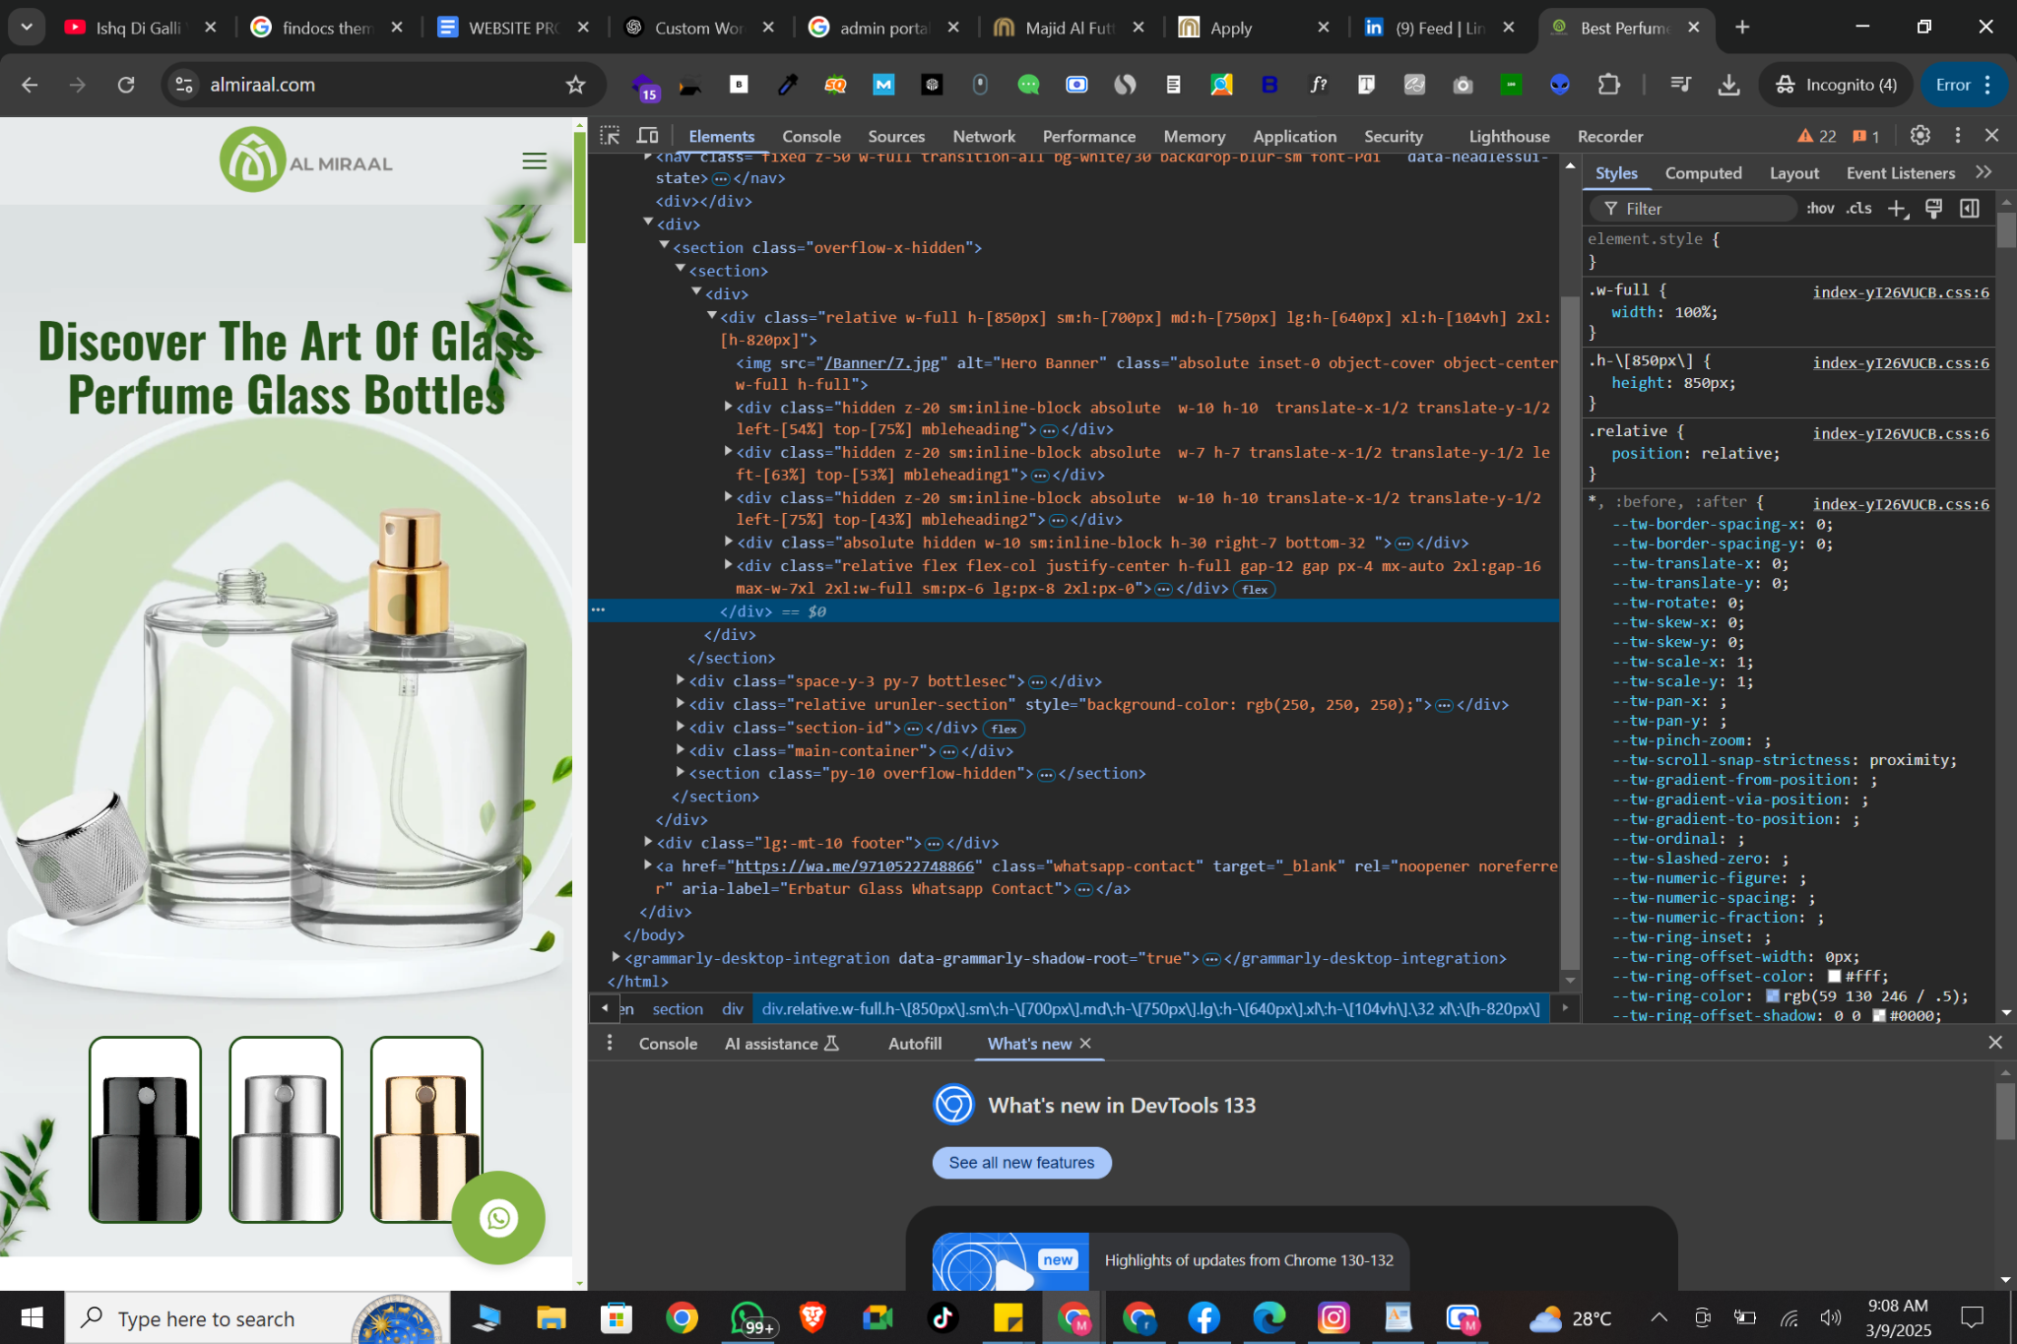

**The entire system, including the frontend, backend, dynamic, CMS, and database, must be custom-developed to match the reference site.**

## A screen recording of the complete website for better understanding:

[screen-capture (4).webm](https://drive.google.com/file/d/1LAywGQ_sZVTDAh2tQVR-T-6cz_LtcH5c/view?usp=sharing)

It should be complete dynamic website.

| Question | Answer |
| --- | --- |
| Timeline and each milestone |  |
| How many phases will this project go through for completion? Please outline each phase that will justified your price quotation |  |
| Is this a One-person Project, or does it require a team? |  |
| How many team members will be involved and what are their designations? (ex: designer,writer etc) |  |
| Are You agency & where you based? |  |
| What challenges do you foresee in this project? I know its doable for you but please mention |  |
| Quote your price in AED for complete project |  |
| Minor Revision Charges like content? In AED |  |
| Minor Revision Charges like add functionality or section? In AED |  |
| Hosting Domain & Email setup charges? In AED |  |
| You Requirements? |  |
| How many meetings you are expecting from client for this project? |  |
| What do you think, how much client involvement will be required to complete this project? Mention in percentage |  |